Expression of Interest

Request for Expression of Interest for Commercial Lease

Description:
Alpine Shire Council is seeking expressions of interest for the lease of commercial space currently occupied and trading as The River Deck Café at the corner of 119 Gavan Street and 16 Howitt Lane, outlined as thatched area in image below. It does not include the roads within this title which shall remain as public access.
Offering approximately 203sqm of lettable space plus 2 car spaces and shared use with the Bright Visitor Information Centre to the female, male and disabled amenities.
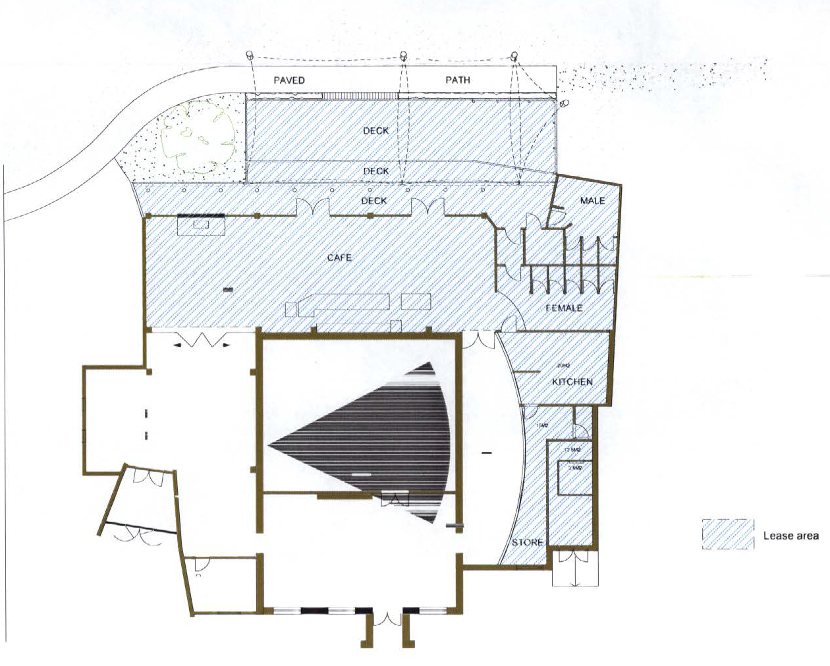
This area is zoned Commercial 1 with annual rent expectations of $38,000 plus GST and outgoings. CPI reviews are conducted annually and a market review at the commencement of each new term. A maximum letting period is set at 3x3x3 years, however, shorter lease terms will be considered. Lease commencement date would be in first half of 2022.

Set out below is the required information for the expression on interest. This information will remain confidential and only be used to assess the application.

Part 1 | Applicants should outline their Business Plan and as a minimum include:  - Product or service offering  - Size of business including staff levels  - Forecasted revenue and expenses  - Current experience  - Trading days and hours  - Letting period  Applicants should be prepared to further discuss in detail the high level business plan they outline below.

Detail any requirements you have of Council in relation to your proposal.
Part 2 | Applicants should outline any requirements they may have of Council as part of their proposal. There is no need to detail items required by law of rental providers.
2

Full Name of Interested Party :_______________________________________________________________________

Company (If applicable):______________________________________________________________________________

ABN (If applicable): ___________________________________________________________________________________

Mailing Address: ______________________________________________________________________________________

Email Address: ________________________________________________________________________________________

Telephone number: __________________________________________________________________________________

Signature: __________________________________________________Date (DD/MM/YYYY): ____________________

Returnable via email to Gloria De Marchi Commercial Officer, gloriad@alpineshire.vic.gov.au
Or a hard copy sent to PO Box 139, Bright VIC 3741 , Bright VIC 3741

All submissions must be received by close of business on Monday, 25 October to be eligible for consideration.

