  ALPINE SHIRE | EXPRESSION OF INTEREST FORM

REQUEST FOR EXPRESSION OF INTEREST NO:

DESCRIPTION:
Land forming part of title 1\TP104783 located within the Reserve on the corner of Ropers Road, Cottrells Lane and Loudens Lane, Tawonga South as outlined in image in dark blue. It does not include the roads within this title which shall remain as public access.

Annual fee payable at the commencement of each financial year: $220 plus GST

Land Images
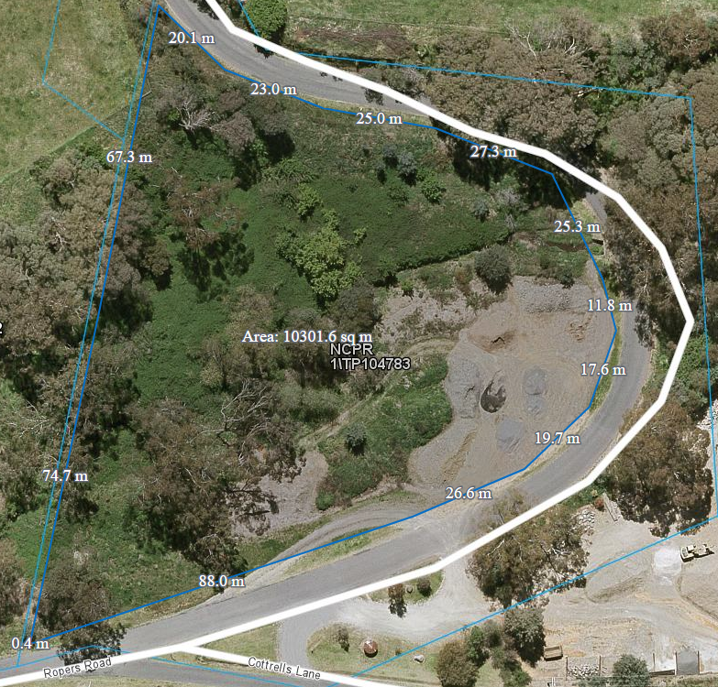

Set out below is the required information for the expression on interest:
Part | Proposed Use of the land
1

Part | Requirements of Council
2

Full Name of Interested Party :_______________________________________________________________________

Company (If applicable):______________________________________________________________________________

ABN (If applicable): ___________________________________________________________________________________

Mailing Address : ______________________________________________________________________________________

Email Address: ________________________________________________________________________________________

Telephone number : __________________________________________________________________________________

Signature : __________________________________________________Date (DD/MM/YYYY): ____________________

Returnable: via email to Gloria De Marchi Commercial Officer, gloriad@alpineshire.vic.gov.au
Or a hard copy sent to PO Box 139, Bright VIC 3741 , Bright VIC 3741
Submissions must be received by close of business on the closing date to be eligible for consideration.

